Travel Portal

Part A
Question No.1
Entity Relationship Diagram (ERD) of Travel Portal:
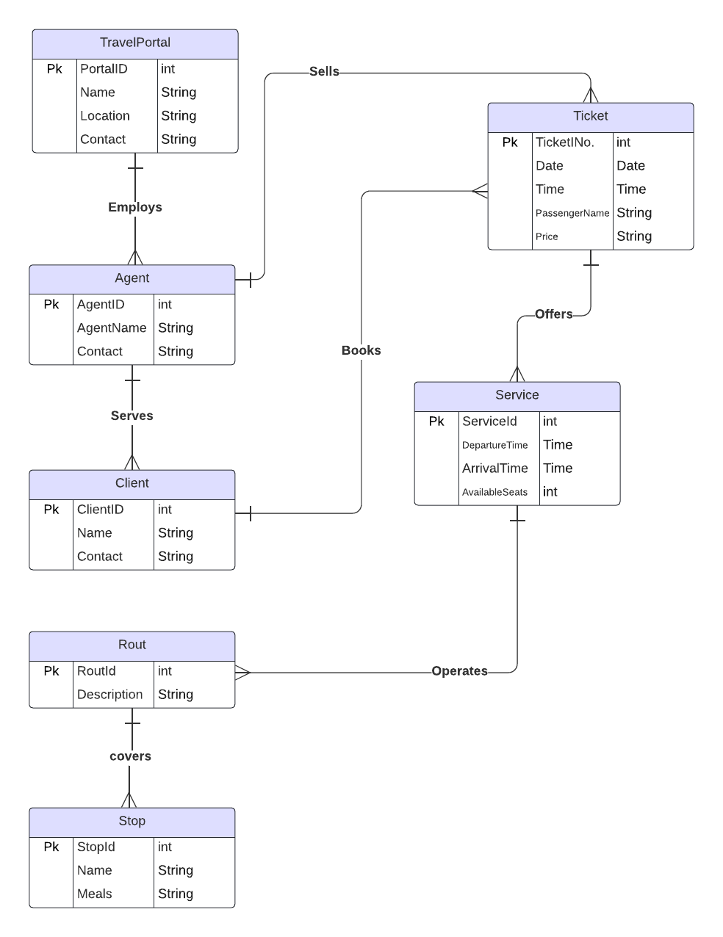

Question No.2
ER Diagram to Relations Mapping to obtained normalized relations

- Travel Portal employs the Agent (1 to many relationship)
Mapping:
TravelPortal
AgentId | PortalId | Name | Location | Contact

Agent
AgentID | AgentName | Contact

- Agent serves the client (1 to many relationship)
Mapping:
Agent
ClientId | AgentID | AgentName | Contact

Client
ClientId | Name | Contact

- Agent sells Ticket (1 to many relationship)
Mapping:
Agent
TicketINo. | AgentID | AgentName | Contact

Ticket
TicketINo. | Date | Time | PassengerName | Price

- Client books tickets (1 to many relationship)
Mapping:
Client
TicketINo. | ClientId | Name | Contact

Ticket
TicketINo. | Date | Time | PassengerName | Price

- Ticket offers service (1 to many relationship)
Mapping:

Ticket
ServiceId | TicketINo. | Date | Time | PassengerName | Price

Service
ServiceId | DepartureTime | ArrivalTime | AvailableSeats

- Service operates route (1 to many relationship)
Mapping:

Service
RouteId | ServiceId | DepartureTime | ArrivalTime | AvailableSeats

Route
RouteId | Description

- Route covers stop (1 to many relationship)
Mapping:

Route
StopId | RouteId | Description

Stop
StopId | Name | Meals

Third Normal Form (3NF):

All these relations are in 3NF, which means they met following criteria:

- 1NF: Each relation contains only one atomic domain per column.
- 2NF: There are no functional dependencies.
- 3NF: There are no transitive dependencies.

Question No.3
Data Dictionary

Table Name | Column Name | Data Types | Description
TravelPortal | PortalId | int | The unique identifier for the travel portal.
TravelPortal | Name | String | The name of the travel portal.
TravelPortal | Location | String | The location of the travel portal.
TravelPortal | Contact | String | The contact information for the travel portal.
Agent | AgentID | int | The unique identifier for the agent.
Agent | AgentName | String | The name of the agent.
Agent | Contact | String | The contact information for the agent.
Client | ClientId | int | The unique identifier for the client.
Client | Name | String | The name of the client.
Client | Contact | String | The contact information for the client.
Ticket | TicketINo | int | The unique identifier for the ticket.
Ticket | Date | Date | The date of the ticket.
Ticket | Time | Time | The time of the ticket.
Ticket | PassengerName | String | The name of the passenger.
Ticket | Price | String | The price of the ticket.
Service | ServiceId | int | The unique identifier for the service.
Service | DepartureTime | Time | The departure time of the service.
Service | ArrivalTime | Time | The arrival time of the service.
Service | AvailableSeats | String | The number of available seats on the service.
Route | RouteId | int | The unique identifier for the route.
Route | Description | String | The description of the route.
Stop | StopId | int | The unique identifier for the stop.
Stop | Name | String | The name of the stop.
Stop | Meals | String | The meals that are served at the stop.

